
National University of Computer and Emerging Sciences

Software Engineering

“Deliverable {1} – {Scheduling Management System}”

STUDENTS NAME and REGISTRATION NUMBERS:
Ali Hamza (Team Lead) 21I-1107
Musa Haroon 21I-1206
Aiyza Junaid 21I-1145
Muneer Ahmed 21I-1179
DEGREE PROGRAM: BSSE
SECTION: P
SUBJECT NAME: Software Engineering
DATE OF SUBMISSION: April 11, 2022
SUBMITTED TO: Mr. Bilal Khalid Dar

STUDENT SIGNATURE:
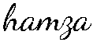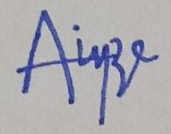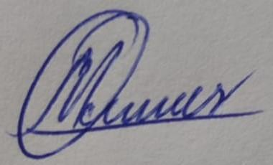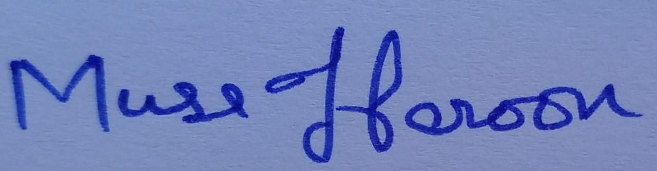

______________________________________________________________
MARKS:

______________________________________________________________
REMARKS:

______________________________________________________________
TEACHERS SIGNATURE:

______________________________________________________________

TABLE OF CONTENTS

- User Stories 3
- Structure Requirement Specification (SRS) 13
- Trello Screenshots 33
- Burndown Chart 35

User Stories
Story ID: 1 Story Title: Sign up using Google/Facebook
User Story: As a student, I want to be able to sign up for Student Diary App using my existing Google or Facebook accounts for easy access.
Acceptance Criteria:
And I know I am done when I can create an account to access the student diary using my Google/GB credentials, without having to create a new username and password.

Story ID: 2 Story Title: reCAPTCHA verification
User Story: As an admin, I want users to use reCAPTCHA when logging in to protect the website/web app from spam and abuse.
Acceptance Criteria:
And I know I am done when the user cannot login to their account unless they have been verified by the reCAPTCHA.

Story ID: 3 Story Title: Manual sign up
User Story: As a student, I want to be able to sign up for the Student Diary App by using my basic information like username , email and password.
Acceptance Criteria:
And I know I am done when I can create an account to access the student diary using basic information like username, email and password.

Story ID: 4 Story Title: Agree to terms and conditions
User Story: As an admin, I want users to agree to the terms and conditions before signup so that they come to know about our terms.
Acceptance Criteria:
And I know I am done when the user cannot sign up to their account unless they have agreed to the conditions.

Story ID: 5 Story Title: Have an account
User Story: As a student, I want that if I already have an account I can go to the login page so I can continue my login process.
Acceptance Criteria:
And I know I am done when I can go to the login page if I already have an account.

Story ID: 6 Story Title: Create an email
User Story: As an admin, I want the user to create an email if he doesn't have so he can continue to signup.
Acceptance Criteria:
And I know I am done when the user can create an email through the link.

Story ID: 7 Story Title: Basic Login
User Story: As a student, I want to be able to log into my account using my username and password to access my data.
Acceptance Criteria:
And I know I am done when I can view my dashboard and all my assignments data after entering my username and password on the login screen.

Story ID: 8 Story Title: Forgot password feature
User Story: As a student, I want to be able to follow a procedure to reset my password in case I forget it or lose access to my account.
Acceptance Criteria:
And I know I am done when I receive an email on the email account associated with my Student Diary profile with a link to reset my password or i am successfully able to change password through backup key.

Story ID: 9 Story Title: Save password
User Story: As a student, I want to save my password for future use so I do not have to enter my password again and again.
Acceptance Criteria:
And I know I am done when I can save my password.

Story ID: 10 Story Title: Login through saved password
User Story: As a student, I want to login to my account by using a saved password so I can access my account quickly.
Acceptance Criteria:
And I know I am done when I can login to my account by using a saved password.

Story ID: 11 Story Title: Create an account
User Story: As a student, I want to have an option of creating a new account on the login page so I can create a new account.
Acceptance Criteria:
And I know I am done when I will move to the sign up page.

Story ID: 12 Story Title: Show password
User Story: As a student, I want an option to see my password if I want to see it during the login process so I can avoid errors.
Acceptance Criteria:
And I know I am done when I have an option to see my password during the login process.

Story ID: 13 Story Title: Upload Assignment and Quiz Dates
User Story: As a student, I want to upload assignment and quiz dates so that I can view all the important dates in one place.
Acceptance Criteria:
And I know I am done when I can view all my assignment dates.

Story ID: 14 Story Title: Date Format for Assignments and Quizzes
User Story:
As a student, I want to add my assignments and quiz dates in day/month/year format so that I know what format to use.
Acceptance Criteria:
And I know I am done when I can view all my assignments and quiz dates in day/month/year format.

Story ID: 15 Story Title: Upload Assignment and Quiz Topics
User Story:
As a student, I want to upload the topics of my assignments and quizzes so that I know which topics are included.
Acceptance Criteria:
And I know I am done when I can view all my topics.

Story ID: 16 Story Title: Add Notes to Assignments and Quizzes
User Story:
As a student, I want to add additional notes in a text box for assignments and quizzes so that it’s easier to navigate through the content.
Acceptance Criteria:
And I know I am done when I can view all my notes.

Story ID: 17 Story Title: Character limit for inputs
User Story:
As a student, I want to know the character limit of my inputs so that I know how much I can write in the text box.
Acceptance Criteria:
And I know I am done when the system limits me from writing out of the limit of 280 characters.

Story ID: 18 Story Title: Mark assignments and quizzes that are complete
User Story:
As a student, I want to mark the assignments and quizzes that have been completed so that I know how much work is left.
Acceptance Criteria:
And I know I am done when I can see the completed assignments and quizzes have been marked.

Story ID: 19 Story Title: Add Marks to Assignments and Quizzes
User Story:
As a student, I want to enter the marks for the assignments and quizzes that have been checked so that I can view my results in one place.
Acceptance Criteria:
And I know I am done when I can view all my marks on screen.

Story ID: 20 Story Title: Drop-down menu to select subjects
User Story:
As a student, I want to select my subjects from a drop-down menu so that my assignments and quizzes are arranged subject wise.
Acceptance Criteria:
And I know I am done when I can view all my subjects in the drop-down menu.

Structure Requirement Specification of User Stories
The structured specifications of the user stories are;
1. Structured Specification for Signup using Facebook/Google account:
Function: Link Google/Facebook accounts.
Description: Provide the service to connect to Google/Facebook to login easily and quickly to the application without having to create a new username and password.
Inputs: Credentials to user’s Google/Facebook account
Source: Student.
Outputs: Creation of a new user account whose info is added into the database of all students
Destination: Signup page.
Action: The user can use the signup with Google or Facebook option and make an account. After the account is made through them, the user can then continue on using the web application.
Requirements: The user must remember their Google/Facebook password.
Pre-condition: The user’s Google/Facebook account must exist.
The application should be connected to Google/Facebook at the backend.
Post-condition: The application’s records will be updated with the creation of a new user account.
The Google/Facebook account’s records will be updated with the new application/site that is now linked with the account.
Side effects: None.
2. Structured Specification for reCAPTCHA verification:
Function: ReCAPTCHA provides security against bots.
Description: CAPTCHA is a test to distinguish spam bots and actual human users, by adding this feature, an extra layer of security is added to the application.
Inputs: Typed text that user has to enter or checkboxes to select based on visual input
Source: Student.
Outputs: Successful login if CAPTCHA is cleared
Destination: Signup page.
Action: User will give a reCAPTCHA test, may it be based on pictures or words, the user will have to pass in order to access or create their account.
Requirements: The user must be able to distinguish between different pictures or alphabets.
Pre-condition: The user’s account must exist. Must connect to Google servers to provide the CAPTCHA service.
Post-condition: The account will be logged in if CAPTCHA is cleared otherwise, the user will be denied access to the account for a specific time period for increased security.
Side effects: None.

3. Structured Specification for manual sign up :
Function: Manual sign up enables user to signup.
Description: Manual sign up is a process of creating an account by using the basic information like user name , email and password.
Inputs: Text fields to receive textual data like user name and password.
Source: Student.
Outputs: Successful creation of account.
Destination: Signup page.
Action: User will have to type the information with the help of keyboard in the required fields.
Requirements: The user must have a unique user name and password. Pre-condition: The user must have a email address existing before.
Post-condition: The user will be able to login using the credentials provided if the sign up is successful.
Side effects: None.

4. Structured Specification for agree to terms and conditions :
Function: Agree to terms and conditions will make sure that user is agreed to the policies.
Description: Agree to terms and conditions is a process of giving rights to the admin to implement his policies.
Inputs: A check box.
Source: Admin.
Outputs:User can continue to signup.
Destination: Signup page.
Action: User will have to click in the required.
Requirements: The user must have a mouse to click the box.
Pre-condition: The user must have to start signup process.
Post-condition: The user will be able to continue to signup process.
Side effects: None.

5. Structured Specification for have an account :
Function: Take the user to the login page.
Description:Have an account enables the user to smoothly move to the login page if he already have an account.
Inputs: Click with the mouse.
Source: Student.
Outputs: Successful moved to the login page.
Destination: Signup page
Action: User will have to click on the link of login so he can move to login page if he already have an account.
Requirements: The user must have a mouse to click.
Pre-condition:User must have an account and currently he should be on signup page.
Post-condition:The user can continue to login if he clicked the link.
Side effects: None.

6. Structured Specification for create an email :
Function: The user will move to the gmail signup.
Description:Create an email enables the user to create a new gmail if he doesn't have.
Inputs: Click with the mouse.
Source: Admin.
Outputs: Successful moved to the gmail signup page.
Destination: Signup page
Action: User will have to click on the link of create an email and he will move to gmail signup page.
Requirements: The user must have a mouse to click.
Pre-condition:User must want to create a new gmail account.
Post-condition:The user can continue to create a new gmail account.
Side effects: None.

7. Structured Specification for Basic login:
Function: Will log in the user to their account.
Description: One way to make an account on the app is through username and password. Once these are entered and the user is verified they will be able to access the web application.
Inputs: Distinct username and user-specified password
Source: Student.
Outputs: Displays student’s personal dashboard and gives access to all features of the application
Destination: Login page.
Action: The user will have to enter their set unique username and password in order to login
Requirements: Users must remember their password.
Pre-condition: The user’s account must exist
Post-condition: The account will remain logged in until the user clicks on “Logout”.
Side effects: None.

8. Structured Specification for Forgot password feature:
Function: The user will be able to change password.
Description: In case the user forgets their password, they can click on “Forgot password” to follow a specific procedure to recover their account. They will have to enter their email address to get a link to reset the password.
Inputs: Email address of the email account associated with the user’s Student Diary account or the backup key for the user’s account.
New password which must be different from the password that was forgotten
Source: Student.
Outputs: Generation of an email to the entered email address that contains a link to reset password.
Destination: Login page.
Action: The user will have to press the Forgot Password option, which will give the user the option to either enter a backup key or reset using Email or Facebook. If the backup key option is selected, the user is required to enter the backup ke that was generated through their account. If recovery through Email or Facebook is chosen, the user will have to enter the Email of the account connected to the web application.
Requirements: User must remember the backup key or the Email that is connected to the account.
Pre-condition: The user’s Student Diary account must exist and must be associated with the same email address that was entered.
Post-condition: New password should be updated in all the databases and in the user’s account.
Side effects: None.
9. Structured Specification for save password:
Function: The user will be able to save password.
Description: In case the users want to save their passwords they can save the passwords for the quick access.
Inputs: A check box of save password.
Source: Student.
Outputs:The password will be saved.
Destination: Login page.
Action:The user will have to click the save password box .
Requirements:User must have mouse to click.
Pre-condition:User must have a valid password to store.
Post-condition:The password will be saved if the box is checked.
Side effects: None.

10. Structured Specification for login through saved password:
Function: The user will be able to use save password to login.
Description: In case the users want to login their account by using their already saved passwords they can access.
Inputs: A check box of login through saved password.
Source: Student.
Outputs:The account will be logged in.
Destination: Login page.
Action:The user will have to click the save password box .
Requirements:User must have mouse to click.
Pre-condition:User must have a saved password.
Post-condition:The account will be loggedin if the password was saved.
Side effects: None.

11. Structured Specification for create an account :
Function: Take the user to the signup page.
Description:Create an account enables the user to smoothly move to the signup page if he didn’t have an account.
Inputs: Click with the mouse.
Source: Student.
Outputs: Successful moved to the sign up page.
Destination: Login page
Action: User will have to click on the link of Signup so he can move to signup page.
Requirements: The user must have a mouse to click.
Pre-condition:User wants to create a new account.
Post-condition:The user can create a new account if he clicked the link.
Side effects: None.

12. Structured Specification for show password :
Function:Display the entered password.
Description:Show password enable the users to see the passwords they enterered.
Inputs: Click with the mouse.
Source: Student.
Outputs: Successful display the password.
Destination: Login page
Action: User will have to click on the show password option.
Requirements: The user must have a mouse to click.
Pre-condition:User must have entered the password.
Post-condition:The user will be able to see the entered password.
Side effects: None.

13. Structured Specification for uploading assignment and quiz dates:
Function: Students can upload the due dates for their assignments and quizzes.
Description: Students will be able to upload assignment and quiz dates so that they can view all the important dates in one place.
Inputs: Students will enter their assignment and quiz dates in the text box made for assignment dates.
Source: Student.
Outputs: Students can successfully view their assignment and quiz dates on the screen
Destination: A popup message will appear to show that the assignment and quiz dates are successfully uploaded.
Action: Students can login to the account and then upload their due dates for the upcoming assignments and quizzes. Students cannot upload their assignment and quiz dates if they are not signed up for the app. They shall input their due dates in the boxes provided for assignments and quizzes due dates.
Requirements: The students should know their assignment and quiz dates.
Pre-condition: The student should already be on the website and logged in to upload the assignment and quiz dates.
Post-condition: The assignment and quiz dates will be uploaded which can then be viewed on the screen.
Side effects: None.

14. Structured Specification of date format for assignments and quizzes:
Function: Students can upload the due dates for their assignments and quizzes in the day/month/year format.
Description: Students will be able to add their assignment and quiz dates in day/month/year format so that they know what format to use.
Inputs: Students will enter their assignment and quiz dates in the box made for assignment and quiz dates in the day/month/year format.
Source: Student.
Outputs: Students can successfully view their assignment and quiz dates in day/month/year format on the screen.
Destination: Assignment and quiz page.
Action: Students can use the website to upload their assignment and quiz dates in the day/month/year format. The student cannot upload their assignment dates if they do not have access to the website or if they are not signed up for the app. The student cannot upload their assignment and quiz dates in any other format.
Requirements: Students need to know which date format to use.
Pre-condition: The students should already be on the website and be signed up to the app for the assignment and quiz date format to be accessible and editable.
Post-condition: The assignment and quiz dates will be uploaded in the day/month/year format which can then be viewed on the screen.
Side effects: None.

15. Structured Specification of uploading assignment and quiz topics:
Function: Students can upload the topics for their assignments and quizzes.
Description: Students will be able to add topics included in the assignments and quizzes.
Inputs: Students will enter their assignment dates in the text box made for assignment and quiz topics.
Source: Student.
Outputs: Students can successfully view their assignment and quiz topics on the screen.
Destination: Assignment and quiz page.
Action: Students can use the website to upload their assignment and quiz topics. They can enter the data in the text box provided with all the assignments and quizzes. The option to enter topics will be available on every student’s website. The option shall be available on every account.
Requirements: Students need to know the topics included in their assignments and quizzes.
Pre-condition: The student should already be on the website and be signed up to the app for the assignment and quiz topics to be accessible and editable.
Post-condition: The assignment and quiz topics will be uploaded which can then be viewed on the screen.
Side effects: None.

16. Structured Specification of adding notes to assignments and quizzes:
Function: Students can add notes with their assignment and quiz topics.
Description: Students will be able to add additional notes in a text box for assignments and quizzes for them to navigate through the content easily.
Inputs: Students will enter their notes in the text box.
Source: Student.
Outputs: Students will be able to view their written notes in the text box on the screen.
Destination: A popup message will appear to show that the assignment and quiz notes are successfully added.
Action: Students can log in or sign up to upload their notes to assignments and quizzes. They can enter the data in the text box provided with all the assignments and quizzes. The option to add notes will be available on every student’s website. The option shall be available on every account.
Requirements: There is a need for the student to enter the notes in the text box.
Pre-condition: The student should already be on the website and be signed up to the app to add notes. They need to input the data for it to later be accessible and editable.
Post-condition: The notes can be viewed on the screen.
Side effects: None.

17. Structured Specification of character limit for inputs:
Function: System will restrict the user to enter within the limit of 280 characters for the inputs.
Description: Students need to know the character limit of their inputs from them to know how much they can write in the text box.
Inputs: Students will enter their inputs in the text box.
Source: Through the student account by inputting.
Outputs: Students will be restricted from entering characters greater than 280 characters in the text box.
Destination: A popup message will appear to show that the input is successfully uploaded within the limit of 280 characters.
Action: Students can log in or sign up to write in notes or add topics for assignments and quizzes. They can enter the data in the text box provided with all the assignments and quizzes within the limitation of 280 characters. A warning message will appear in case the input exceeds the limit. The user will be asked to input data again.
Requirements: Students need to be aware of the character limit. There is a need for the student to enter any input in the text box.
Pre-condition: The student should already be on the website and be signed up to the app. They need to input any data for the limitation to work.
Post-condition: the character limit feature will be implemented. In case the limit exceeds, a warning message will be displayed. The user will be asked to input data again.
Side effects: None.

18. Structured Specification for marking the completion of assignments and quizzes:
Function: Students can mark the assignments and quizzes that have been completed.
Description: Students will be able mark the assignments and quizzes that have been completed for them to know much work is left.
Inputs: Students will mark the assignments and quizzes in the check box.
Source: Student.
Outputs: Students will be able to know the assignments and quizzes that are completed by viewing the check box on the screen.
Destination: Assignment and quiz page
Action: Students can log in or sign up to mark the assignments and quizzes that have been completed. Our system will have an option to mark the assignments and quizzes that are complete by ticking the checkbox. This option will be available on every student’s website. The option shall be available on every account.
Requirements: Students need to know which assignments or quizzes have been completed. There is a need for the student to mark the assignments and quizzes in the check box.
Pre-condition: The student should already be on the website and be signed up to the app to mark their assignment and quiz completion.
Post-condition: The assignments and quizzes marked can be viewed on the screen.
Side effects: None.

19. Structured Specification of adding marks to assignments and quizzes:
Function: Students will be able to add marks with their assignments and quizzes.
Description: Students will be able enter the marks for the assignments and quizzes that have been checked so that they can view my results in one place.
Inputs: Students will enter their marks in the box provided with every completed assignment and quiz.
Source: Student.
Outputs: Students will be able to view their marks of assignments and quizzes on the screen.
Destination: Assignment and quiz page.
Action: Students can log in or sign up to upload the marks of the assignments and quizzes that have been checked. They can enter and store the marks in the box provided with every assignment and quiz that has been marked as complete. The option to enter marks of completed assignments and quizzes will be available in every account for all subjects.
Requirements: Students need to know their marks in assignments and quizzes to enter marks. The students can only enter marks for the assignments and quizzes that are marked complete.
Pre-condition: The student should already be on the website. They should be signed up to the app to add marks.
Post-condition: The entered marks can be viewed on the screen.
Side effects: None.

20. Structured Specification for selecting subjects from a drop-down menu:
Function: Students can select the subjects from a drop-down menu.
Description: Students will be able to select any subjects from a drop-down menu so that they can access assignments and quizzes arranged subject wise.
Inputs: Students can access the subjects by clicking on the drop-down menu.
Source: Student.
Outputs: Students can view all their subjects on the screen.
Destination: Users will be moved to the selected subject page.
Action: Students can log in or sign up to access the drop-down menu. They can select the desired subjects to go to assignments and quizzes through this option. The option to select subjects will be available in every account.
Requirements: Students should know which subject they want to choose.
Pre-condition: The student should already be on the website. They should be signed up to the app to select subjects from the drop-down menu.
Post-condition: The assignments and quizzes of the selected subject can be viewed on the screen.
Side effects: None.

Trello Screenshots:
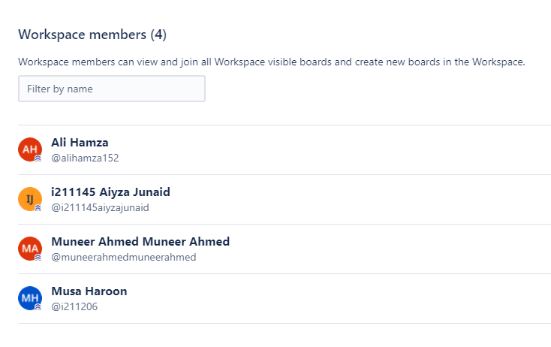
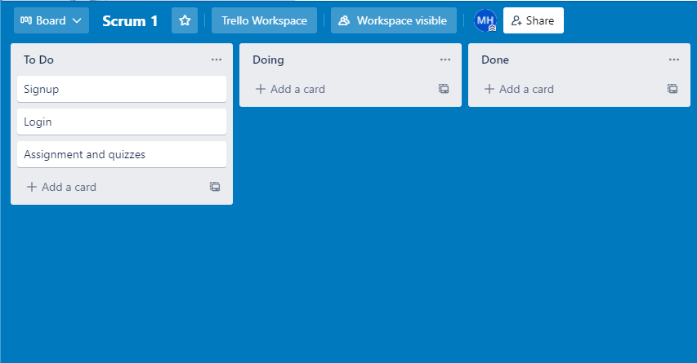
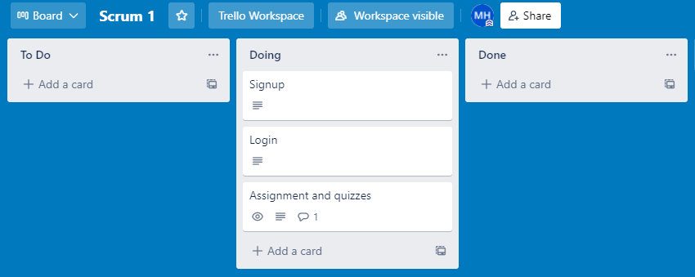
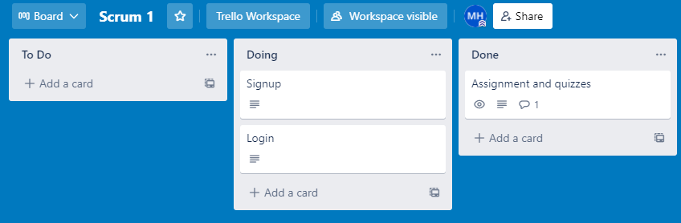
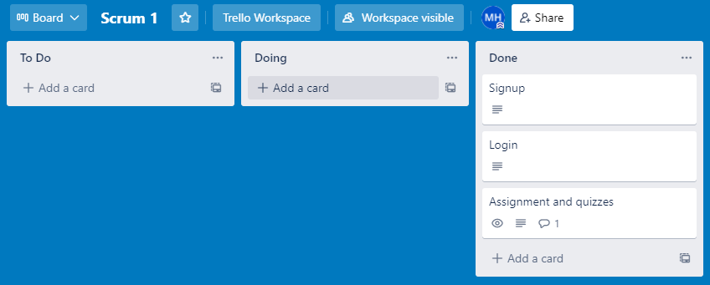

Burndown Chart:

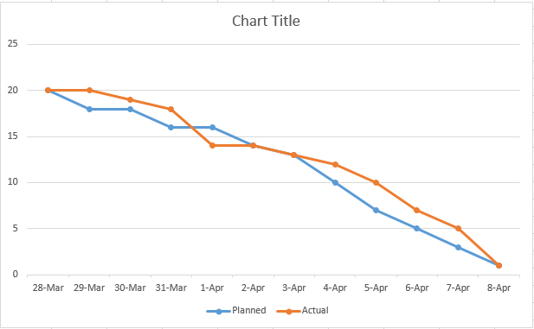

==*-- THE END --*==

